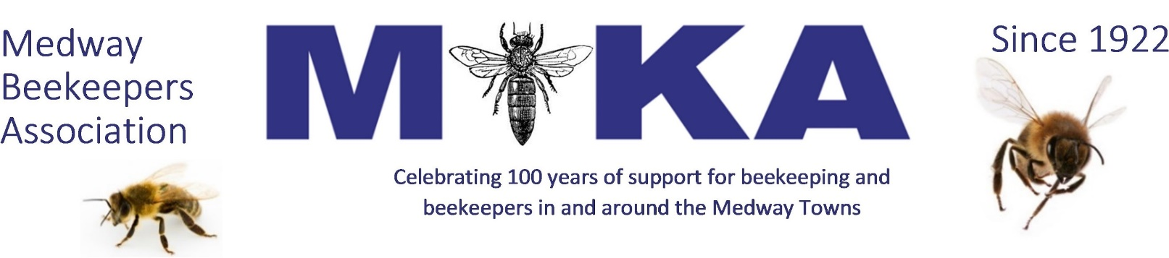
NEW MEMBER SUBSCRIPTION 2022
You can pay the 2022 subscription at £32.00 immediately and be a member until 31st December 2022. As a full member, you receive BBKA NEWS monthly as well as third party insurance and the first 3 hives for Bee Diseases Insurance.
Associate membership is unchanged for 2022 at £10.00. This has no BBKA membership nor any insurance. It is designed for non-beekeepers and members of other beekeeping organisations.
Junior membership at £1.00 has been introduced for people under 18 years old on 1 January 2022. Benefits as for Associate membership.
The cost of Bee Craft magazine is very good value at £30.00. This is a 15% discount on the cover price. For new subscribers the first copy will be June to fit in with our annual bulk order. You will receive 12 issues until May 2023.
Complete the details below and then return this form (or your details) to the Treasurer,
Archie McLellan, 10A Sandgate Court, Rainham, GILLINGHAM ME8 8TQ. Email: archie.mclellan@medwaybeekeepers.co.uk
BBKA Full Member | £32:00
Associate or non-beekeeper member (excludes BBKA) | £10:00
Junior Member (under 18) | £1:00
BeeCraft 1 Year Subscription | £30.00
Bee Disease Insurance: additional colonies premium
Donation
Total payment
Your name
Address including postcode

Phone
Email
Payment may be made by cheque (to Medway Beekeepers Association) or by bank transfer. The details are
Account name Medway Beekeepers Association
Sort Code 09-01-50
Account number 05195829
Reference your initials and last name
When providing your personal details you consent to their use by MBKA in line with its Privacy Policy, which is available to view on our website www.medwaybeekeepers.co.uk. If you would like a printed copy please contact the Secretary. MBKA will never share your personal details with anyone outside of those stated in this policy without your prior consent.
NOTES: Bee Craft – payments strictly by 31st March please. Bee Disease Insurance: ALL colonies, nuclei or swarms, must be insured, regardless of size. For premiums paid after 31st March insurance only valid 41 days later!
ADDITIONAL PREMIUMS FOR BEE DISEASES INSURANCE (max 39 colonies)
First 3 colonies FREE | 2 extra colonies £ 2.00 | 7 extra colonies £ 5.25
12 extra colonies £ 7.75 | 17 extra colonies £ 9.50 | 22 extra colonies £11.10
27 extra colonies £13.60 | 32 extra colonies £16.10 | 36 extra colonies £18.10

